Chapter 1
Statistics-What & why

Introduction:
In this chapter we discuss history of Statistics, Definition, function, characteristic, Scopes, Application of Statistics in Business management. And finally we discuss the limitation od Statistics.

History of Statistics:
The word Statistics have been derived from Latin word” Status” or the Italian word “Statista”, meaning of these word is “Political State” or a Government. Shakespeare used a word Statist in his drama Hamlet(1602). In the past. The statistics was used by rulers. The applications of Statistics was very limited but rulers and kings needed information about lands, agriculture, commerce, population of their states to assess their military potential, their wealth, taxation and other aspects of Government.

Gonfried Achenwall used the word Statistik at a German University in 1749 which mean that political Science of different countries. In 1771 W.Hooper(englishman) used the word Statistics in his translation in elements of Universal Erudation written by Baron B.F Bieford, in his book statistics has been defined as the Science that teaches us what is the political arrangement of all the modern states of the known world. There is a big gap between the old Statistics and the modern Statistics. But old Statistics used as a part of the present Statistics.

During the 18th century the English writer have used the word Statistics in their work, so Statistics has developed gradually during last few centuries. A lot of work has been done in the end of the 19th century.

At the beginning of the 20th century William S Gosset was developed the methods for decision making based on small set of data. During the 20th century several Statistician are active in developing new methods, theories and application of Statistics. Now these days the availability of electronic computer in certainly a major factor in the modern development of Statistics.

Definition of Statistics:
Statistics like many other sciences is a developing discipline. It is not nothing Static, it has gradually developed during last few centuries. In different times, it has been defined in different manners. Some definitions of the past look very strange today but those definitions had their place in their own time. Defining a subject has always been difficult task. A good definition of today maybe discarded in future. It is difficult to define Statistics. Some of the definitions are reproduced here:

- The kings are rulers in the ancient times were interested in their manpower. They conducted census of population to get information about their population. They used information to calculate their strength and ability for wars. In those days Statistics was defined as
“the science of kings, political and science of statecraft”

- A.L Bowley defined Statistics as :
“Statistics is the science of counting”
This definition places the entries stress on counting only. A common man also thinks as Statistics is nothing but counting. This used to be the situation but very long time ago. Statistics today is not mere counting of people, counting of animal, counting of trees and counting of fighting force. It has now grown to a rich methods of data analysis and interpretation.

- A.L Bowley also defined as :
“Science of average”
This definition is very simple but it covers only some area od Statistics. Average is very simple important in Statistics. Experts are interested in average death rates, average birth rates, average increase in population, and average increase in per capita income, average increase in standard of living and cost, average development rate, average inflation rate, average production of rice per acre, average literacy and many others average of different fields of practical life. But Statistics is not limited to average only. There are many other Statistical tools like measure and variation, measure of correlation, measures of independence etc…. Thus this definition is weak and incomplete and has been buried in the past.

- Prof. Boddington has defined Statistics as :
“Science of estimate and probabilities”
This definition covers major part of Statistics.it is close to the modern Statistics. It is not complete because it stress only on probability. There are some areas which probability is not used.

- A definition due to W.I.King is :
“the science of Statistics is the method of judging collection,
Natural or social phenomena from the results obtained from
The analysis or enumeration or collection of estimates”
This definition is close to the modern Statistics. But it does not cover the entire scope of modern Statistics. Secrist has given a detailed definition of Statistics in plural sense. Statistics both in the singular and the plural sense has been combined in the following definition which is accepted as the modern definition of Statistics.

“Statistics are the numerical statement of facts capable of analysis and interpretation and the science of statistics in the study of the principals and the methods applied in collecting, presenting, analysis and interpreting the numerical data in any field of inquiry.”

Statistics: Statistics can be defined as the science of collection, organization, presentation, analysis and interpretation of numerical Data
- Collection: collection of data constitutes the first step in a Statistical investigation. The data maybe available from existing published and unpublished sources or collect by the investigator himself.
- Organization: Data collected from published sources are generally in organized form. However, a mass figures that are collected from a survey frequently needs organization. The first step in organizing a mass of data is editing (omission, inconsistencies, irrelevant answers, wrong computation; etc). After the data edited the next step is to classify them. The last step in organization is tabulation.
- Presentation: After the data have been collected and organized, they are ready for presentation. Data presented in an orderly manner facilitates statistical analysis.
- Analysis: After Collection, Organization and Presentation the next step is that of analysis. Methods sued in analyzing the presented data are numerous ranging from simple observation of data complicated, sophisticated and highly mathematical techniques.
- Interpretation: The last stage in Statistics investigation in interpretation. I.e, drawing conclusion from the data collected and analyzed. The interpretation of data is a difficult task and necessitates a high degree of skill and experience.

Functions:
- It represents facts in a definite form.
- It simplifies mass of figures.
- It facilitates comparison.
- It helps in formulating and testing hypothesis.
- It helps in prediction.
- It helps in the formulation of suitable policies.

Characteristics of Statistics: Some of its important characteristics are given below.
- Statistics are aggregates of facts.
- Statistics are numerically expressed.
- Statistics are affected to a marked extent by multiplicity of causes.
- Statistics are enumerated or estimated according to a reasonable standard of accuracy.
- Statistics are collected for predetermine purpose.
- Statistics are collected in a systemic manner.
- Statistics must be comparable to each other.

Scope of Statistics: In the real world, there are no sectors where Statistics can't be used. Some scopes of' Statistics are given below:
- Statistics if Agricultures.
- Statistics in Planning.
- Statistics in Economics.
- Statistics in Business management.
- Statistics in Industry.
- Statistics in the State.
- Statistics in Biology.
- Statistics in Psychology.
- Statistics in Education.
- Statistics in Medicine etc.

Statistics in Business Management: The following are some major activities of a typical, large and progressive organization which would indicate how Statistics helps in the management of Business enterprise.
1. Marketing: Statistical analyses are frequently used in providing information for making decisions. In the field of marketing, it is necessary first to find out what can be sold and then evolve a suitable strategy so that goods reach the ultimate consumer.
2. Production: In the field of production, statistical data and statistical methods play a very important role. To decision about what to produce, how much to produce, when to produce, for whom to produce, is based largely on facts analyzed statistically. Statistical tools are also of immense help in quality control.
3. Finance: The financial managers in discharging their finance function efficiently depend heavily on statistical analysis of facts and figures.
4. Banking: In banking, the bankers use the objective analysis furnished by statistics and then temper their decisions on the basis of qualitative information.
5. Investment: Statistics greatly assists invest to in making clear and valued judgment in his investment, decision in selecting securities which are safe and which have the best prospects of yielding a good income.
6. Purchase: The purchase department in discharging it functions makes use of statistical data to frame suitable purchase policies such as from where to buy, how much to buy, at which time to buy and at what price to buy.
7. Accounting: Statistical methods are also employed in accounting. In particular, the auditing function uses Sampling and estimation and the cost accounts use regression analysis.
8. Control: The management control process combined Statistical and accounting methods in making the overall budget for the coming year.
9. Credit: the credit department performs statistical analysis to determine how much credit to extend to customers.
10. Personnel: the personnel department frames personnel policies based on facts to use Statistical studies.
11. Research and Development: many big organizations have research development department which are primarily concerned with finding out how existing products can be improved by using Statistical analysis.

Shortcomings/Drawback/Limitations:
- Statistics does not deal with isolated measurements.
- Statistics deals only with quantitative characteristics.
- Statistics does not study for individuals.
- Statistical results are true on the average.
- Statistics usually collects data through sample survey and comments on the population characteristics.
- Statistics can be misused.

2nd Chapter
Data Collection & Presentation

Introduction: in this chapter we discuss variables and some related topics of variable.
Population: population means an aggregate of elements processing certain characteristic of interest in any particular investigation or inquiry. It is generally named after the characteristics studied. It maybe finite or infinite.
Example: if we are interest to investigate the previous results of a group of students in UITS Rajshahi campus then all the students of that group together comprise the population.

Sample: A sample in the representative part of a population. That is a sample is a set of n observations drawn from the population.
Example: results of some students in a group in UITS Rajshahi campus.

Variable: The measurements of elements of a population having certain characteristics may vary from element either in magnitude or in quality. These measurable characteristics are called variable. Generally, variables represented by x, y, z etc.

Constant: if the characteristics of the measurement of element of a population do not change element to element, then these measurable characteristics are called constant. Generally, its denoted by a, b, c etc.
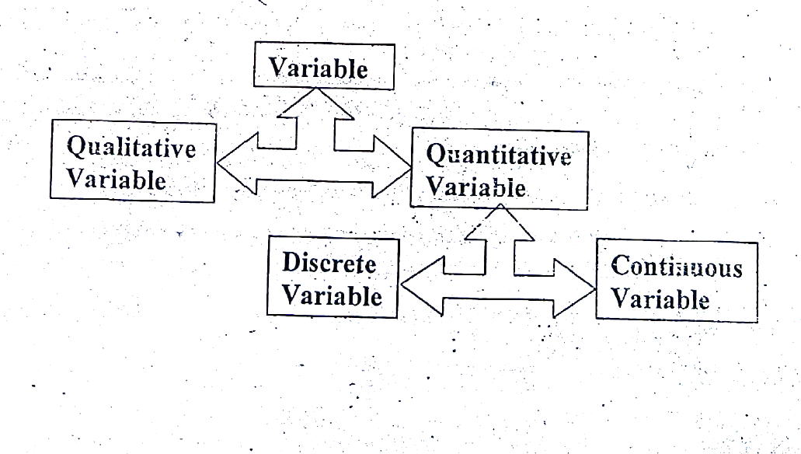

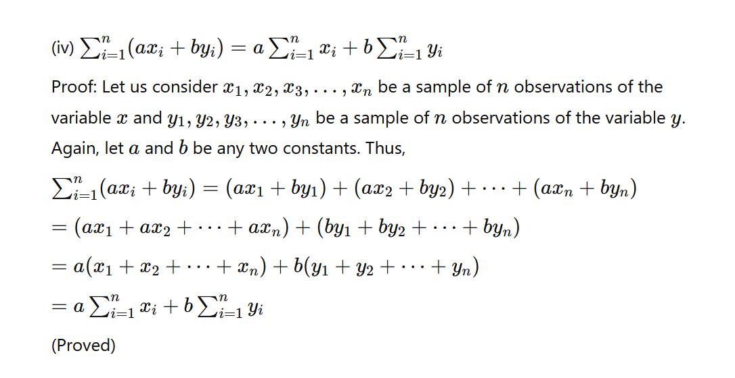
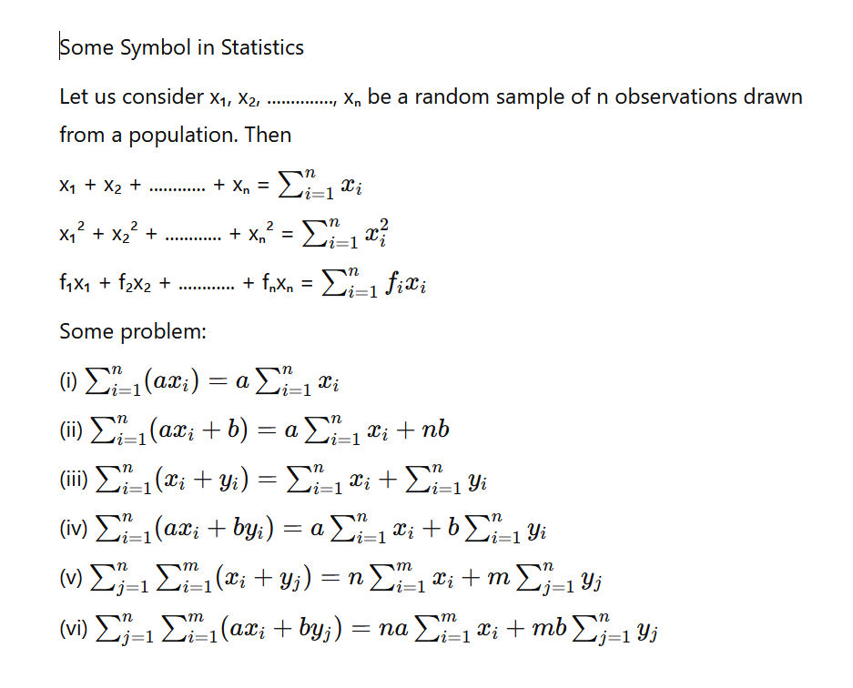
Some Symbol in Statistics:

Data: For any investigation, this collections of raw materials from the investigation field are called data.
There are two types of data,
- Statistics Tables
- Statistics charts.

1.Staristics Tables:
- Classification
- Tabulation
- Frequency Distribution
2.Statistics Charts:
- Histogram
- Bar diagram
- Frequency polygon
- Frequency Curves
- Ogive Curves

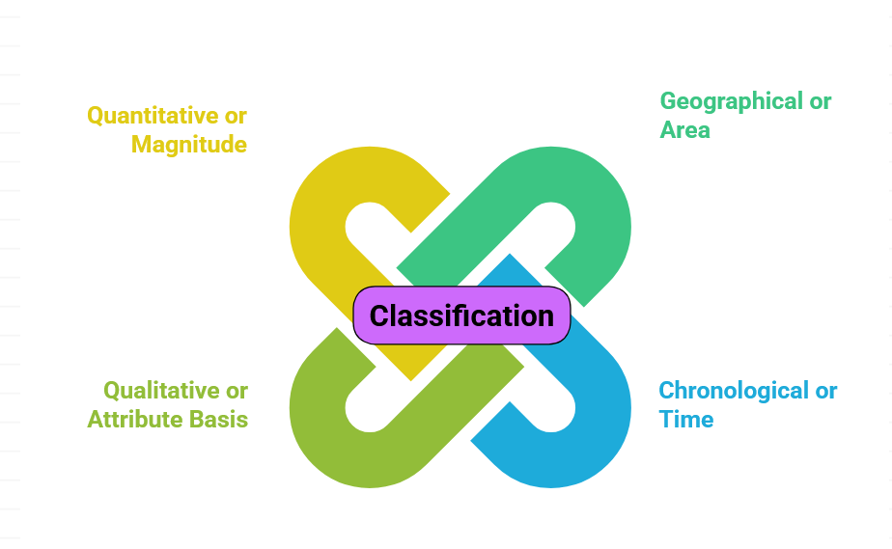
Classification: Data can be classified in the following way:
Tabulation: A good table contains the following parts/points:
- Table number
- Title of the table
- Stab head of the table
- Caption of the table
- Body of the table
- Foot note
- Source note

Structure of a good table:
Title of the table
Stub head of the table | Caption of the table
Row Description | Body of the table
**Frequency Distribution: Arrangement of observational data according to frequency of the observations is called frequency distribution.

Using the following steps we can construct a frequency distribution:
- Finding the Range
- Decision about the number of classes
- Choosing the number of class interval
- Give Tick marks or tally marks
- Counting of frequency

Step of preparing frequency distribution: the following steps are followed in constructing a frequency distribution.
- Each frequency should be started with a short, concise and self-explanatory title.
- There are rows and columns of a frequency table, where rows are used to present the number of observations against individual values of the variable. The first column headed by “Class interval” have same rows. The second column headed by “Tally marks” is used to indicate the number of observations belonging to a class. The third column headed by “frequency” is used to present the number of observations of a class. The fourth column headed by “Cumulative frequency” present the number of observations below an upper limit of the class, or number of observations from some lower limit and above of the class. The cumulative observation is done either from top of the class or from bottom of a class. Sometimes fifth columns is used to present the mid-value of the class.
- Decision regarding number of classes and class interval: Let X₍₁₎,X₍₂₎, ……
….. , X_{(n)} are the n sample observations arranged in a array, where X_{(n)} is the highest value and where X₍₁₎ is the lowest value in the series, Then Range(R)= X_{(n)} - X₍₁₎

Let, k be the number classes in a frequency table. The value of k can be found out by the mathematical formula:
K = 1 + 3.33log₁₀(N)
This rule for k is known as Sturge’s rule for number of classes.

Where N is the total number of observations in our given series.
One the value of k is decided, the interval(h) of a class is found by, h=$\frac{R}{k}$

- Class limit: Every class has a lower limit and an upper limit, such as:
a-(a+h), (a+h)-(a+2h), ………. , {a+(k-1)h} – (a + kh)
- Width of class: the difference between upper limit and lower limit of a class is known as width of a class and it is, usually denoted by h, where, h = (a + h) – a
- Tally marks: it is tally sign used to indicate the accommodation of an observation to a particular class. The tally marks facilitate the count of frequencies of a class.
- Frequency: the total tally marks of a class in the frequency of that class.

#Example: the following data represent the number of workers in a different small-scale industry in a country.
19 | 25 | 28 | 32 | 26 | 25 | 25 | 20 | 20 | 22 | 24 | 26 | 28 | 30 | 35 | 32
17 | 20 | 22 | 22 | 24 | 25 | 26 | 28 | 20 | 18 | 26 | 28 | 30 | 30 | 32 | 34
31 | 36 | 30 | 35 | 28 | 27 | 21 | 24 | 20 | 18 | 15 | 15 | 15 | 18 | 20 | 22
36 | 26 | 21 | 23 | 24 | 26 | 28 | 30 | 32 | 34 | 28 | 27 | 15 | 20 | 19 | 26
16 | 24 | 20 | 18 | 20 | 20 | 24 | 27 | 25 | 25 | 25 | 26 | 20 | 21 | 20 | 28
17 | 30 | 32 | 33 | 30 | 28 | 26 | 24 | 26 | 24 | 20 | 18 | 19 | 18 | 15 | 16
23 | 18 | 15 | 17 | 18 | 20 | 20 | 18 | 18 | 19 | 20 | 21 | 27 | 25 | 26 | 19
29 | 20 | 24 | 26 | 27 | 29 | 30 | 32 | 34 | 28 | 30 | 27 | 26 | 28 | 28 | 33
Construct a frequency distribution using suitable class interval.

Solution: Here we have,
N=128
X₍₁₎ = 15 and X_{(n)} = 36
R = X_{(n)} - X₍₁₎ = 36 - 15 = 21

K = 1 + 3.33 log₁₀(N)
= 1 + 3.33 log₁₀(128)
= 8.017
$≈$ 8

Class interval, h=$\frac{R}{k}$
=$\frac{21}{8}$ = 2.63 $≈$3

The distribution of industries by number of workers.
Class interval | Mid-value  X₍₁₎ | Tally marks | Frequency  f_{(i)} | Cumulative frequency  (C.F)
 |  |  |  | From top | From bottom
15 - 18 | 16.5 | |||| |||| || | 12 | 12 | 128
18 - 21 | 19.5 | |||| |||| |||| |||| |||| |||| | | 31 | 43 | 116
21 - 24 | 22.5 | |||| |||| | 10 | 53 | 85
24 - 27 | 25.5 | |||| |||| |||| |||| |||| |||| | 30 | 83 | 75
27 - 30 | 31.5 | |||| |||| |||| |||| | 20 | 103 | 45
30 - 33 | 31.5 | |||| |||| |||| | | 16 | 119 | 25
33 - 36 | 34.5 | |||| || | 7 | 126 | 9
36+ | 37.5 | || | 2 | 128 | 2

Importance of frequency distribution: some importance of frequency distribution given below:
- Frequency distribution represent data by short and simple way.
- By frequency distribution data can be collected and restored by short time and less labore.
- With the help of frequency distribution data can be presented by different graph and charts/Diagrams.
- We can easily find central Tendency, Dispersion, Moment, Skewness and kurtosis of the data by frequency distribution.
- For the same class interval, two or more distribution can be compared by frequency distribution.

***Discuss how you draw or construct different charts***
- *Histogram: To construct a histogram, we put class interval in the X-axis and the frequencies in the Y-axis.

- Bar diagram: to construct a Bardiagram, we put class interval or time or place in the X-axis and the frequencies to the Y-axis.

- Frequency polygon: to construct a frequency polygon, we put class mid point in the X-axis and the Frequencies of the class interval in the Y-axis and add the points sequencely by straight line. And then attach lowest limit and highest limit by dot(.)

- *Frequency curve: to construct a frequency curve, we put mid point in the X-axis and the frequencies of the class interval in the Y-axis and add the points secuencely by free hand.

- Ogive curve: To construct Ogive curve, er put upper limit of the class interval in the X-axis and the Cumulative frequencies in the Y-axis, Finally add these points by free hand

- Historigram: to construct a Historigram, we put Time in the X-axis and the value of the time series variable in the Y-axis. Finally add these points by straight line.

Chapter 3
Central Tendency

Definition: in a representative sample, the values of a series data have a tendency to cluster around a certain point usually at the center of the series. This tendency of a clustering the values around the center of the series is usually called central tendency. And its numerical measures are called the measures of central tendency(location).

When we have a large number of observations in a data set we need to organize the data by constructing frequency distribution to understand the trend and pattern in the data set. However, managers and / or decision-makers might be interested to know which value or values in a data set mostly represent the raw data or the frequency distribution. That is, in most cases we need more exact measures. For the purpose, opportunities summary indices must therefore be obtained. Such index describes the central point or the most characteristic value of the measurement. The summary indices that represent central point of the data set measures the central tendency of data.

Question: What are the requisites of an idea measure of central tendency?
Answer: According to professor Yule the following are the chief characteristics of an ideal measure of central tendency:
- It should be rigidly defined.
- It should be easily understanding and easy to calculate
- Its should be based upon all the observations
- It should be suitable for further algebraic treatment
- It should be affected as small as possible by sampling functions
- It should not be affected much by the extreme values.

Measures of central Tendency: The numerical central value of a set observation is called measures of central tendency. Measures of central tendency are also called the measures of location. Such measures are:
- Arithmetic mean (A.M.)
- Geometric mean (G.M.)
- Harmonic mean (H.M.)
- Median
- Mode

Arithmetic mean (A.M.): the arithmetic mean is the quantity obtained by dividing the sum of the values of a series by the number of items. If x_{1,} x_{2, ……….}x_{n} are the observations, then the arithmetic mean $\overline{X}$ (X bar) is given by,

$$for ungrouped data, A.M. \overline{X}=\frac{1}{n}\sum_{i=1}^{n}{X_{i}}$$

where, n= No. of items
X_{i}= The values of the i^{th} item

$$for grouped data, A.M. \overline{X}=\frac{1}{n}\sum_{i=1}^{n}{{f_{i}X}_{i}}$$
where,
k = No. of classes
X_{i} = The mid value of the corresponding class of grouped data on continuous frequency distribution.
f_{i} = Frequency values of the corresponding class
$$N=\sum_{i=1}^{k}{f_{i}}$$
If A.M. is calculated from sample data, then it will be called the sample mean. For population, it is denoted by $μ$ (Mu).

Question: The advantages and disadvantages of the measures of central latency?
Answer: Advantages of arithmetic mean:
    - It is rigidly defined and easy to calculated
    - It is easy to understand and suitable to algebraic treatment
    - It is based upon all the observations
    - It is least affected by the computation of combined mean

Disadvantages of arithmetic mean:
- It cannot be determined by inspection not it can be located graphically
- It cannot be used if we are dealing with qualitative characteristics, which cannot be measured quantitatively.
- It cannot be obtained if a single observation is missing or lost or is illegible unless we drop it out and compute the arithmetic mean of the remaining values
- It is affected vary much by extreme values.

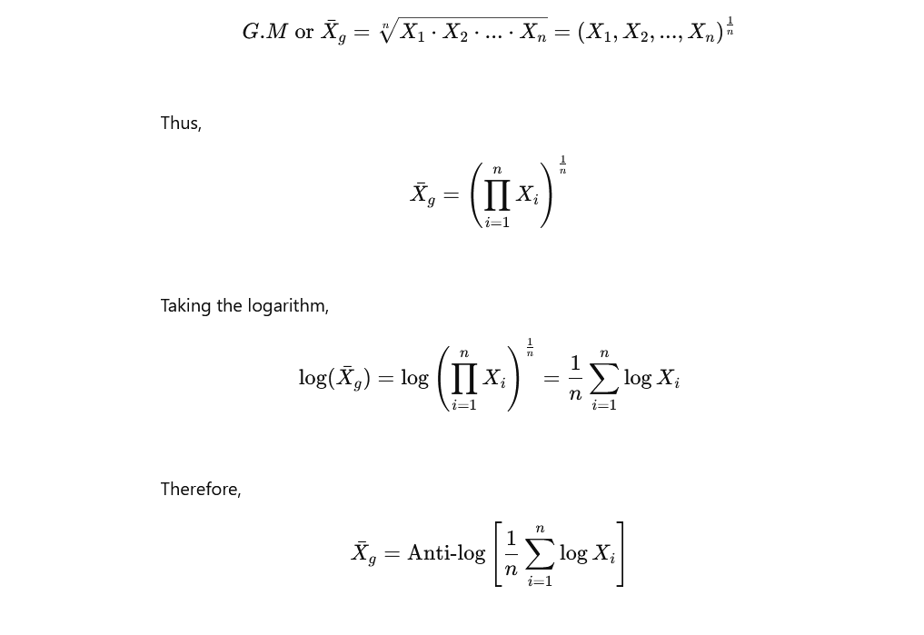
Geometric Mean (G.M): The geometric mean (G.M) is computed by multiplying the n quantities together and taking the nth root of the product.
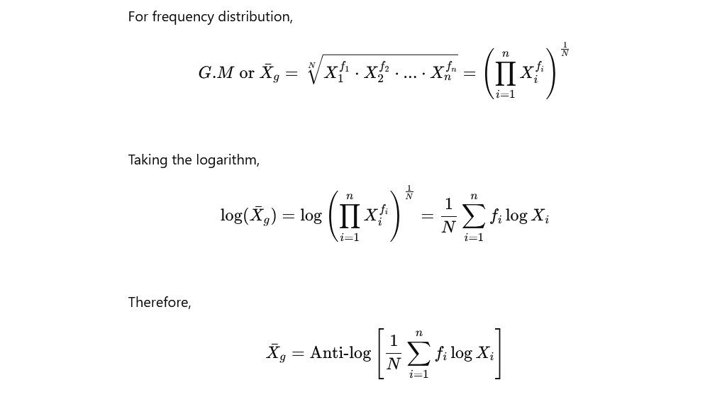
Advantages of geometric mean:
- It is rigidly defined
- It is capable to mathematical treatment
- It is based upon all the observation
- It gives comparatively more weight to small items
- It is not affected much by sampling fluctuations.

Disadvantages of geometric mean:
- It is difficult to calculate end is not easy to understand
- It cannot be calculated where there any zero or odd number of observations is negative in the series.
- It is impossible to calculate if the extreme class of the frequency distribution is open.
- The value of the geometric mean may not occur in the classes.

Harmonic mean (H.M.): The harmonic mean id defined as the reciprocal of the arithmetic mean of the reciprocals of the individuals values.
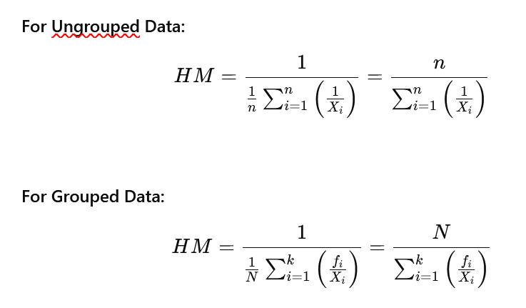
Advantages of harmonic mean:
- It is rigidly defined
- It is easy to further mathematical treatment
- It is based upon all the observations
- It is not affected much by sampling fluctuations
- It is greater importance to small observations

Disadvantages of harmonic mean:
- It is not easy to understand and difficult to calculate
- It is impossible to calculate if the extreme classes of the frequency distribution are open
- It is not at all affected by extreme values.

Median: The median is a single value of the data set that measures the central item in the data. It is the middle most or most central item in the set of observations, when the data points arranged in order of magnitude, either is ascending order, half of the items or observations lie above this (median) value and the other lie below it. Let the data set contains in data points (observations) and these are arranged in order of magnitude.
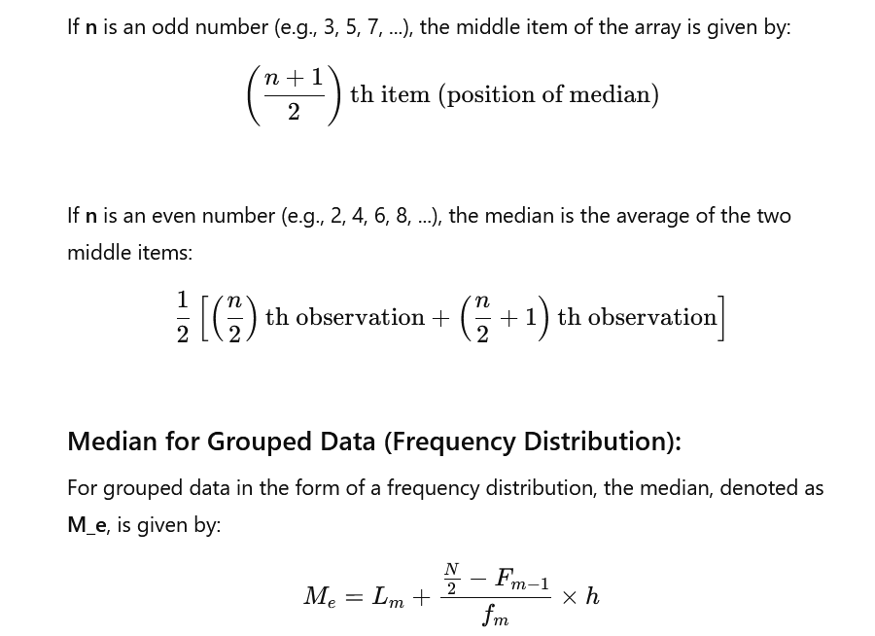

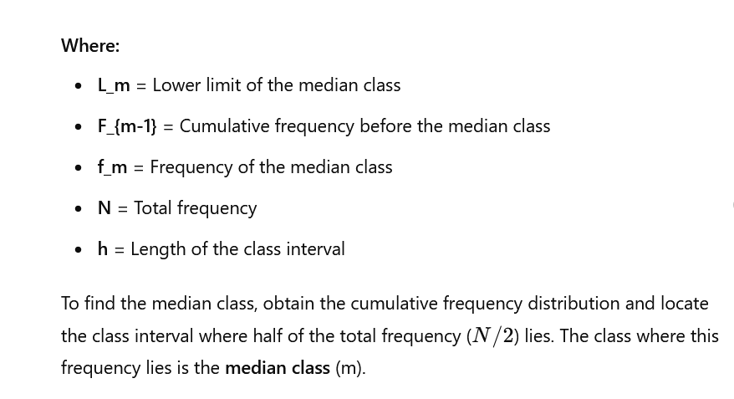

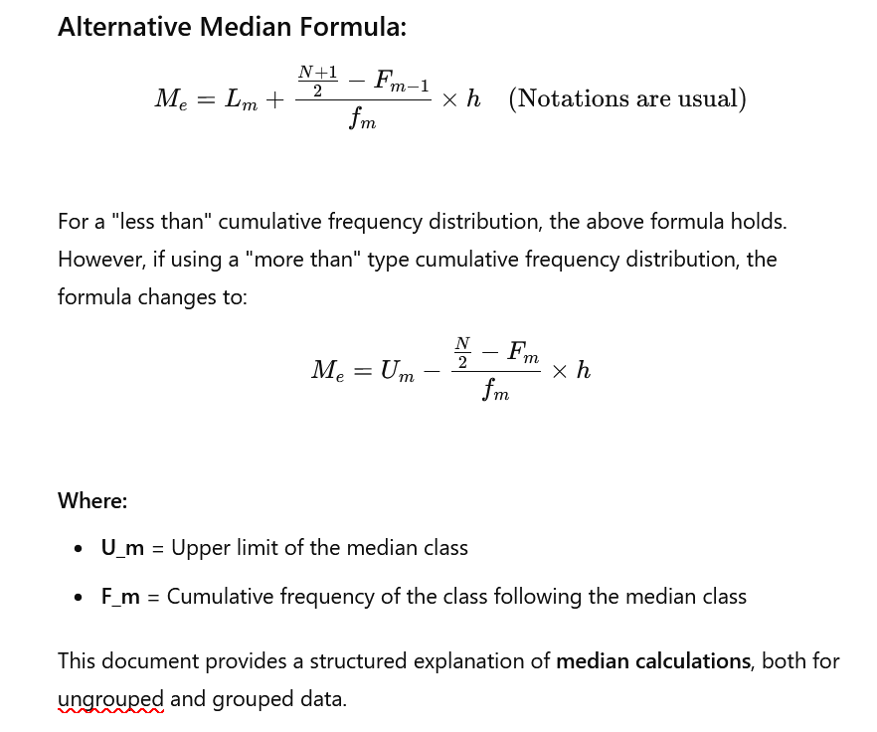


Median can be found out using ogive and the histogram.

Advantages of median:
  - It is rigidly defined
  - It is easy to understand and difficult to calculate
  - It is not at all affected by extreme values
  - It can be calculated from the frequency distribution with open end
  - It can be located graphically.

Disadvantages of median:
- It is not based on all the observations
- It is not easy for algebraic treatment
- It is affected much by sampling fluctuation.
The median does not permit the calculation of the median of medians.

Mode: The mode is that value of the observations which is repeated most often in the data set. In other word, mode is the value of a variable, which repeats maximum items in a frequency distribution, mode is such a value for which the frequency is maximum.

For ungrouped data find out a data point or an observation that repeats maximum items in the data set. Easy way of finding the mode from a raw data is to arrange the observations in order of magnitude and notice which observation occurs maximum times -that observation in the mode.
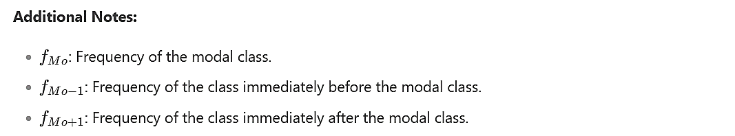
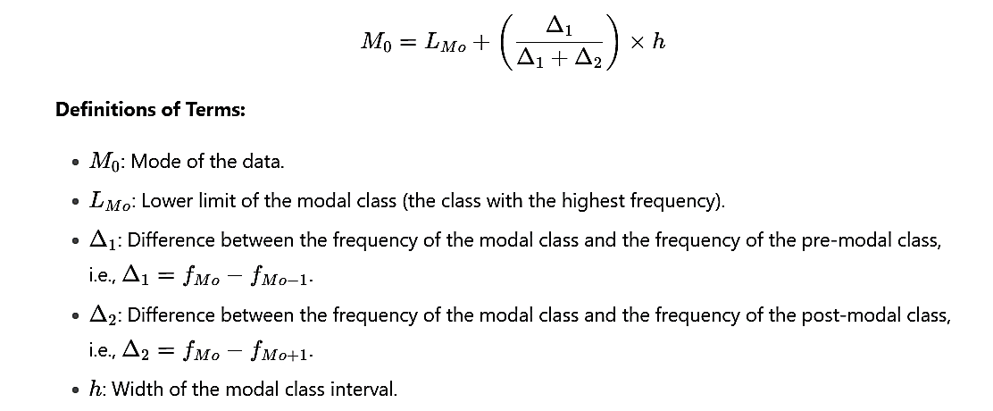
For group of data. We find modes using the formula:

Advantage of Mode:
- It is easy to understand and easy to calculate
- It is not at all affected by extreme values
- It can be calculated from the frequency distribution with open class.

Disadvantage of Mode:
- It is not clearly defined in case of bimodal or multi-modal distribution.
- It is not based on all the observation
- It is difficult for algebraic treatment
- Mode is affected to a great extent by sampling fluctuations.

In order to find Mode: Locate the modal class (M₀) of the frequency distribution. The class interval where the maximum frequency lies, is the modal of the distribution.
Mode can be found out graphically, using histogram.

Comparing Mean, Median and Mode: When to use mean, median and mode as the measure of central tendency. For symmetric distribution, always:
Mean = Median = Mode.
For skewed distribution median is the best measure of location because it is always between the mean and the mode. If the data set contain extreme value, better not-use mean, because mean is influenced by the outlier. Also for open-anded frequency distribution better to use median or mode, not mean. For highly skewed distribution, mode should not be used as a measure of central tendency of data. In case of raw data if the variation among the data points are very small better use mean. Except the effect of outlier mean is chosen to be the best measure since it is based on all observations.

It should be noted here that there is no guidelines for applying the mean, median and mode as the measure of central tendency.

When to use AM, GM and HM:
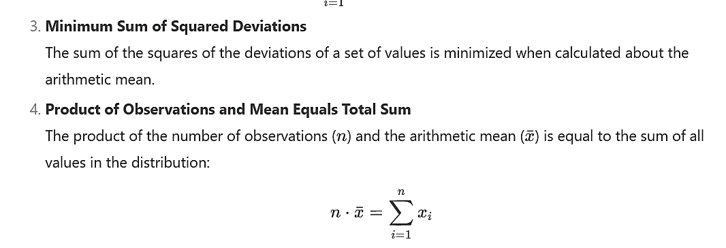
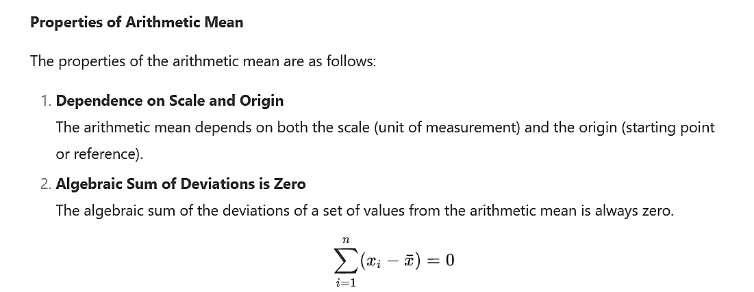
Since AM, GM and HM are all based on all observations, any data point that is zero, calculation of GM and HM is note possible. Therefore AM is the only measure of location. If the observations are given in rates, GM is better measure. HM is used when rate is expressed as X per Y & X is constant – such as miles per hour, income per household, production on per acre and so on. If Y is constant, AM is used.
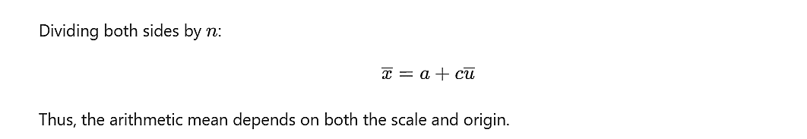

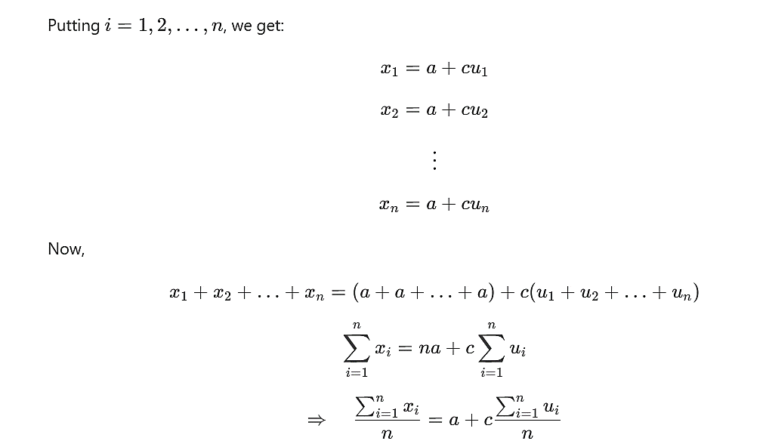
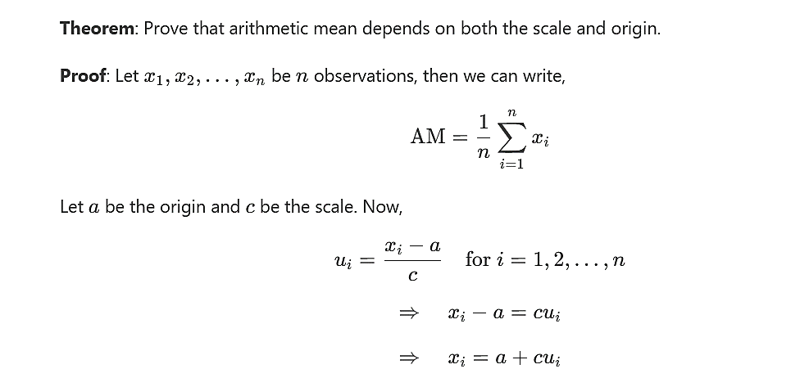
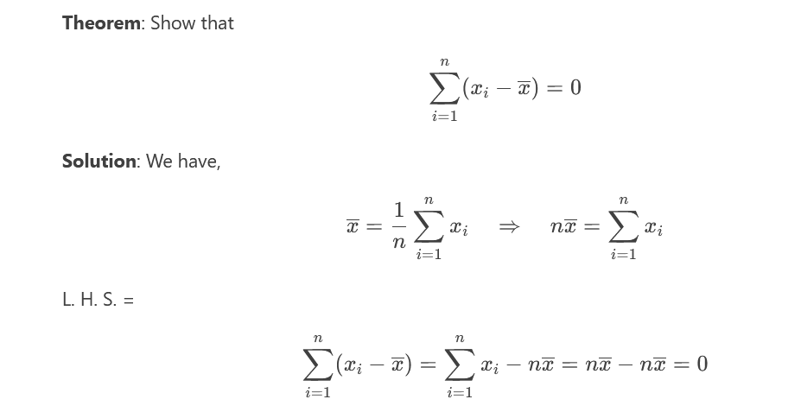







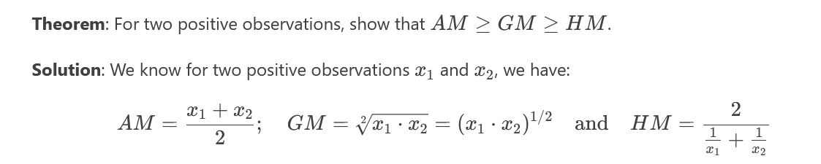

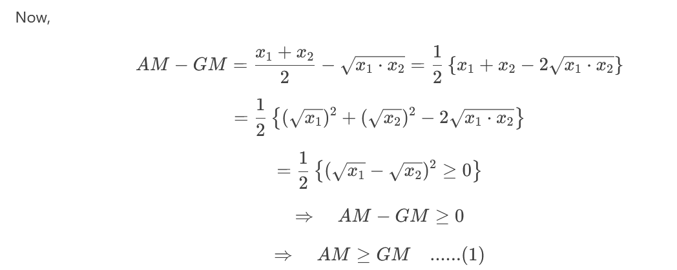

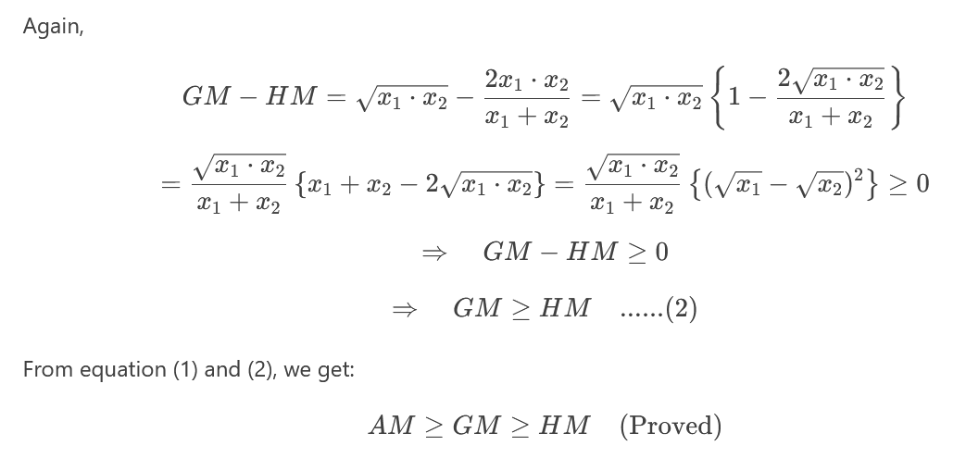

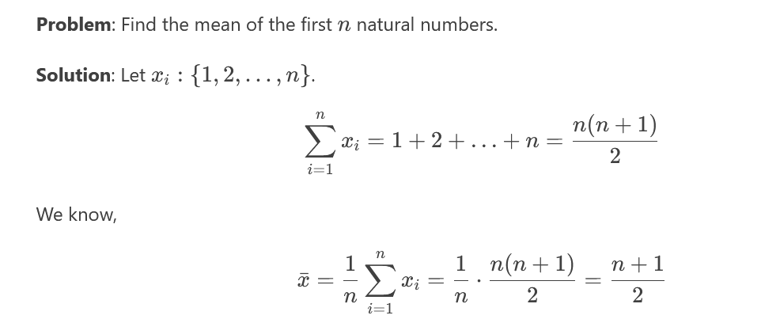

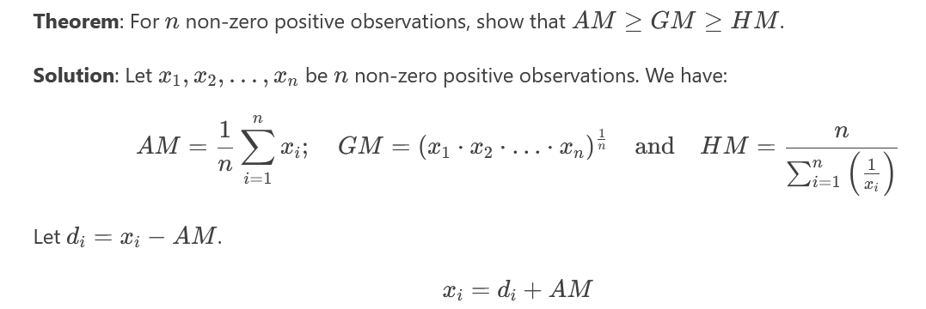

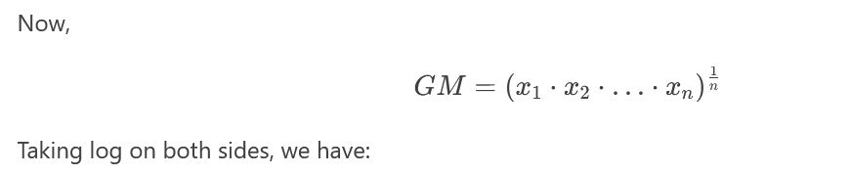



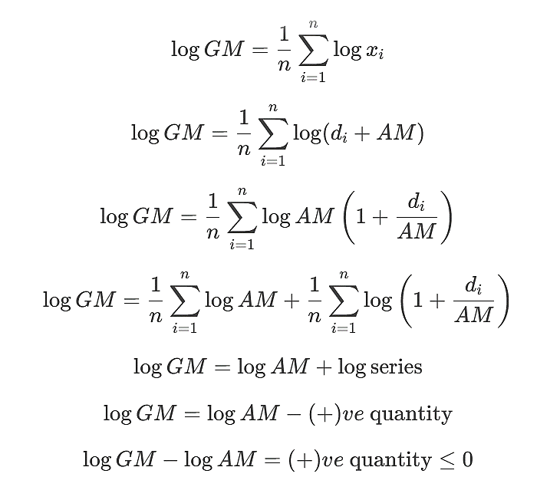

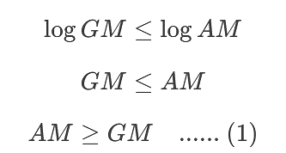

Again, we have,
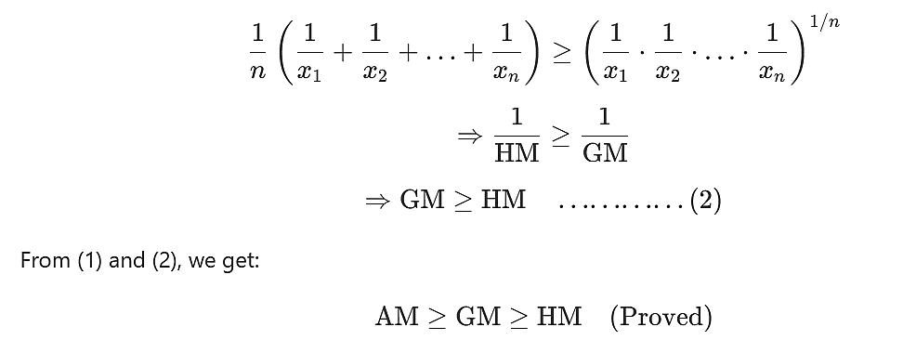

Question: what is the best measure of central tendency?
Ans: There are five measures of central tendency. The measure which is suitable in every purpose of central tendency and which measure satisfy the average is the best measure of central tendency.

Let us consider that the arithmetic mean is the best measure central tendency because:
- It should be rigidly defined.
- It should be suitable for further arithmetic treatment
- It should be easily understanding and easy to calculate
- Its permit the computation of the combined mean
- It should be based upon all the observation
- It should be affected as small as possible by sampling fluctuation.

Now, let us consider the mode for grouped observations of data. It is not clearly defined and is not based upon all the observations, and it is difficult for further algebraic treatment. So, it is not the best measure of central tendency.
From the above discussion, only the arithmetic mean satisfies all ideal properties of central tendency, and the other four measures of central tendency fulfill partially. So, we may conclude that the arithmetic mean is the best measure of central tendency.
Quartiles: Quartiles are the measures of location of data. For raw data, the complete data set is first arranged in order of magnitude, thus quartiles are obtained. The first quartile, denoted by Q₁​, is that value in the data set for which 25% (1/4) of the total observations lie below that value and 75% (3/4) of the total observations lie above that value. Q₃​, the third quartile, is that value for which 75% (3/4) of all observations lie above that value. Following the concept, Q₂​ is nothing but the median.
For grouped data in the form of frequency distribution, the quartiles are calculated as follows:
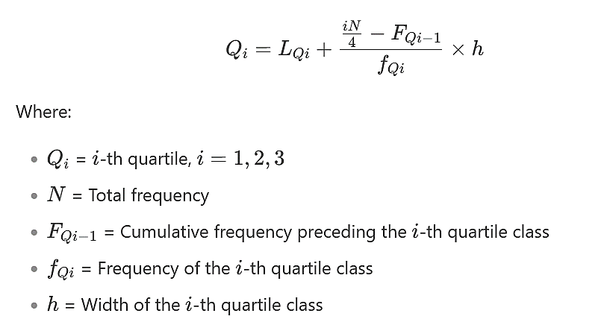
In order to find the quartiles, we have to locate where Q₁​, the first quartile (25% of total frequency or N/4), and the third quartile Q₃​ (75% or 3N/4 of total observations) lie. Once we are able to locate the quartile class interval, we can readily find out the quartiles (Q₁​ & Q₃​) using the above formula.
Deciles: When the observations are divided into 10 equal parts, we can calculate deciles D₁,D₂,…,D₉D₁​ is related to the first 10% (or 1/10) of all observations, D₂​ is related to the second 10% or 20% (2/10) of all observations, and so on.
For frequency distribution,

Probability

Experiment: It is an act which can be departed under certain identical condition. Example, tossing a coin , throwing a dice ….

Random experiment: Experiment are called random experiments if the outcomes depend or chance cannot be predicted with certainly. Example, tossing a coin, tossing a dice, Drawing cards from a bridge deck etc..

Trial: Aunit sample experiment is called trial. Example, tossing a coin one time..

Sample space: The collection or totality of all possible outcomes of a random experiment is called sample space. It is usually denoted by S .
Example: if we toss a coin, the sample space is.
S = { H , T }, where H = head, T = tail
Of the coin respectively
If a dice is thrown, the sample space is,
S = { 1,2,3,4,5,6 }

Sample point: An element of the sample space is called a sample point. Sample point usually denoted by small letters.
If S or $Ω$ = { 1,2,3,4,5,6 }
Then, 1,2… etc are sample point

Event: An event is a subset of the sample space for which the sample points in the subset have some specific common properties.
If S or $Ω$ = { HH,HT,TH,TT }
Then A = { HH.HT } is an event

Mutually exclusive event: If A and B be two events in the sample space $Ω$ or S, then they are said to be mutually exclusive event if $A∩B=∅$. That is two events are said to be mutually exclusive if they have no common points.
Example, Let S or $Ω$ = { HH,HT,TH,TT }
And A = { HH }, B = { TT }
Since $A∩B=∅$, thus A and B are mutually Exclusive events.

Equally likely event: Events are said to be equally when one doesn’t occur more often than the others, or events are said to be equally likely. If the probability of occurrence of the events are equal.
Example, A={H}. B={T}, A,B are equally likely.

Dependent Event: An event is said to be dependent event if the occurrence of the event is depending on the other events. Example, two cards drawn from a pack, then the occurrence of the second card is depended on the first card (with/without replacement).

Independent Event: An event is said to be independent event of the occurrence of the event if the is independent to the others event. Let, A and B be two events,
then A and B are said to be independent if $P\left(A∩B\right)=P\left(A\right)⋅P\left(B\right)$

Probability of event: mathematical muqsens of chance of an event is called probability of event. [ copilot: The probability of an event is a numerical measure of how likely the event is to occur. It ranges from 0 (impossible) to 1 (certain) ]

Probability: if S or $Ω$ be a sample space of size $n$, $n\left(S\right)=n$ and A is an event of size $m,$ then the probability of the event A is denoted by p(A) and defined as

$P\left(A\right)=\frac{Number of favourable outcomes of event A }{Total number of outcomes of the sample space}$
$=\frac{n\left(A\right)}{n\left(S\right)}=\frac{m}{n}$
$P\left(A\right)=\frac{m}{n}$
Additive law of probability for two mutually exclusive events:
Statement: if A and B be two mutually exclusive events from a sample space S, then, $P\left(A∪B\right)=P\left(A\right)+P\left(B\right)$
Proof: let A and B be two mutually exclusive events from a sample space.
S

A

B

Again,
The total number of sample points in the sample space, $n\left(S\right)=n$
The favorable sample points of event A, $n\left(A\right)=na$
“ “ “ “ “ B, $n\left(B\right)=nb$

thus, $P\left(A\right)=\frac{na}{n}$ and $P\left(B\right)=\frac{nb}{n}$
since A and B are mutually exclusive so,
$n\left(A∪B\right)=n\left(A\right)+n\left(B\right)=na+nb$

Now, $P\left(A∪B\right)=\frac{n\left(A∪B\right)}{n\left(S\right)}$
$=\frac{n\left(A\right)+n\left(B\right)}{n\left(S\right)}$
$=\frac{na+nb}{n}=\frac{na}{n}+\frac{nb}{n}$
$∴P\left(A ∪ B\right)=P\left(A\right)+P(B)$
[proved]

Similarly for their mutually exclusive events,
$$P\left(A ∪ B ∪C\right)=P\left(A\right)+P\left(B\right)+P(C)$$

Proof: Let us consider, A and B be two not mutually exclusive events from a simple space S.
S

A

B

Again let,

The total number of sample points in the sample space, $n\left(S\right)=n$
The favorable sample points of event A, $n\left(A\right)=na$
“ “ “ “ “ B, $n\left(B\right)=nb$
“ “ “ “ “ $A∩B$, $n\left(A∩B\right)=nab$
Thus,
$P\left(A\right)=\frac{n\left(A\right)}{n\left(S\right)}=\frac{na}{n}$
$P\left(B\right)=\frac{n\left(B\right)}{n\left(S\right)}=\frac{nb}{n}$
And,
, $P\left(A∩B\right)=\frac{n\left(A∩B\right)}{n(S)}=\frac{nab}{n}$

Since A and B be two not mutually exclusive events,
Thus, $\left(A∪B\right)=\left(A∩\overline{B}\right)∪\left(A∩B\right)∪\left(\overline{A}∩B\right)$
$n\left(A∪B\right)=n\left(A∩\overline{B}\right)+n\left(A∩B\right)+n\left(\overline{A}∩B\right)$
$=\left(na-nab\right)+nab+\left(nb-nab\right)$
$=na+ab-nab$

$∴$ $P\left(A∩B\right)=\frac{n\left(A∪B\right)}{n\left(S\right)}=\frac{na+nb-nab}{n}=\frac{na}{n}+\frac{nb}{n}-\frac{nab}{n}$
$=P\left(A\right)+P(B)-P\left(A∩B\right)$

[proved]

#Multiplicative law of probability for two dependent events:
Statement: If A and B be two dependent events, then
$∴$ $P\left(A∩B\right)=P\left(A\right).P\left(B/A\right)=P\left(B\right).P\left(A/B\right)$
Proof: let,
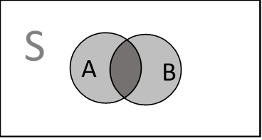
A and B be two dependent event in S
Again let,
The number of sample points in S, $n\left(S\right)=n$
The number of favorable sample point of A, $n\left(A\right)=na$
“ “ “ “ “ B, $n\left(B\right)=nb$
“ “ “ “ “ $\left(A∩B\right)$, $n\left(A∩B\right)=nab$

Thus, $P\left(A\right)=\frac{na}{n}$, $P\left(B\right)=\frac{nb}{n}$,
$P\left(A/B\right)=\frac{nab}{n}$, $P\left(B/A\right)=\frac{nab}{na}$
If B depend on A, then
$∴$ $P\left(A∩B\right)=\frac{nab}{n}=\frac{na}{n} .\frac{nab}{na}= P\left(A\right).P\left(B/A\right)$
If A depend on B, then
$∴$ $P\left(A∩B\right)=\frac{nab}{n}=\frac{na}{n} .\frac{nab}{na}= P\left(B\right).P\left(A/B\right)$

[proved]

#Multiplicaive law of probability for two independent events:
Statement: if A and B are two independent events, then
$P\left(A∩B\right)=P\left(A\right).P(B)$
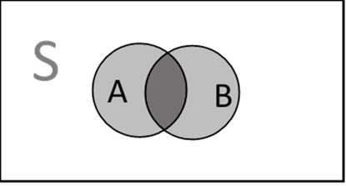
Proof: Let A and B be two independent events is a sample space.
Again let,
The total number of sample points in S, $n\left(S\right)=n$
The number of favorable sample point of A, $n\left(A\right)=na$
“ “ “ “ “ B, $n\left(B\right)=nb$
“ “ “ “ “ $\left(A∩B\right)$, $n\left(A∩B\right)=nab$

Thus, $P\left(A\right)=\frac{na}{n}$, $P\left(B\right)=\frac{nb}{n}$,
$P\left(A/B\right)=\frac{nab}{n}$, $P\left(B/A\right)=\frac{nab}{na}$

$∴$ $P\left(A∩B\right)=\frac{nab}{n}=\frac{na}{n} .\frac{nab}{na}= P\left(A\right).P\left(B/A\right)$
$=P\left(A\right).P\left(B\right) [ ∴$, $P\left(B/A\right)=P\left(B\right) ]$

$∴$ $P\left(A∩B\right)=\frac{nab}{n}=\frac{nb}{n} .\frac{nab}{na}= P\left(B\right).P\left(A/B\right)$
$=P\left(A\right).P\left(B\right) [ ∴$, $P\left(A/B\right)=P\left(A\right) ]$

[proved]

#Prove that,
- 0$≤P\left(A\right)≤1$
- $P\left(A\right)+P\left(\overline{A} \right)=1$
- $P\left(∅\right)=0$

- Proof: Let, A be an event from a sample space S, where,
The total number of sample points in S $=n$
The number of favorable sample points in A = $m$
Thus,
The probability of event A, $P\left(A\right)=\frac{m}{n}$
There arises some situation in event A,
- No favorable outcomes, m=0
- All outcomes in favor of A, m=n
- Some outcomes in the sample space in A, 0$<m<n$
Thus, the value of m is lies from 0 to n , that is,
0$<m<n$
Or, $\frac{0}{n}≤\frac{m}{n}≤\frac{n}{n}$
Or, 0 $≤P\left(A\right)≤1$
[proved]

(b)proof: Let A be any event in the sample space , S
So event A and $\overline{A}$ are mutually exclusive and exustive,
Thus,
$A∪\overline{A}=S$
Or, $P(A∪\overline{A})=P(S)$
$P\left(A)+P(\overline{A}\right)=1$ [proved]

(C)proof: Let S be a sample space
Thus, $P(S)=1$
Now, $∅∪S=S$
Or, $P(∅∪S)=P(S)$
Or, $P\left(∅\right)+P(S)=1$
Or, $P\left(∅\right)+1=1$
$P\left(∅\right)=0$
[proved]

If A and B are independent then A and $\overline{B}$ independent,
Proof: Let A and B be two independent event
Thus, $P\left(A∩B\right)=P\left(A\right).P(B)$
Now, $\left(A∩\overline{B}\right)=A-\left(A∩B\right)$
$P\left(A∩\overline{B}\right)=P(A)-P\left(A∩B\right)$
$=P(A)-P\left(A).P(B\right)$
$=P\left(A\right) \{1-P(B)\}$
$=P\left(A).P(\overline{B}\right)$
Thus A and $\overline{B}$ also independent
[proved]

If A and B independent then $\overline{A}$ and B also independent,
Proof: Let A and B be two independent event
Thus, $P\left(A∩B\right)=P\left(A\right).P(B)$
Now, $\left(\overline{A}∩B\right)=B-\left(A∩B\right)$
$P\left(\overline{A}∩\overline{B}\right)=P(B)-P\left(A∩B\right)$
$=P(B)-P\left(A).P(B\right)$
$=P\left(B\right) \{1-P(A)\}$
$=P\left(B).P(\overline{A}\right)$
Thus $\overline{A}$ and B also independent
[proved]

###
$$\left(A∩\overline{B}\right)=\left(\overline{A∪B}\right)$$
$$P\left(\overline{A}∩\overline{B}\right)=P\left(\overline{A∪B}\right)=1-P(A∪B)$$
$=1-\{P\left(A\right)+P\left(B\right)-P\left(A∩B\right)\}$
$=1-P\left(A\right)-P\left(B\right)+P\left(A\right).P(B)$
$=\{\left(1-P\left(A\right)\right\}-P(B)\{1-P\left(A\right)\}$
$=\left\{1-P\left(A\right)\right\}.\left\{1-P\left(B\right)\right\}$
$=P\left(\overline{A}\right) P(\overline{B})$
Thus if A and B independent then $\overline{A}$ and $\overline{B}$ also independent
[proved]

#there is a survey of 50 student, 40 students get A+ in STA, 30 student get A+ in MATH and 23 students get A+ in both. If a student is select at random , what is the probability that the student is fail to get A+ , either in STA or MATH ?
Solution: let S be the sample space
Event A = get A+ in STA
Event B = get A+ in MATH
Thus
$n\left(S\right)=50, n\left(A\right)=40, n\left(B\right)=30, n\left(A∩B\right)=25$
Thus the probability that the student get A+ either STA or MATH
$P\left(A∪B\right)=P\left(A\right)+P\left(B\right)-P\left(A∩B\right)$
$=\frac{40}{50}+\frac{30}{50}-\frac{25}{50}$
$=\frac{4}{5}+\frac{3}{5}-\frac{1}{2}$
$=\frac{8+6-5}{10}$
$=\frac{9}{10}$
Hence the selected student is fail to get A+ either STA or MATH is
$P\left(\overline{A∪B}\right)=1-P(A∪B)$
$=1-\frac{9}{10}$
$=\frac{10-9}{10}$
$=\frac{1}{10}$
Ans.

#Student A and B can Solve 75% and 50%problems respectively of a book, what is the probability that either A or B can solve any randomly selected problem of the book?
Solve: given that,
$P\left(A\right)=\frac{75}{100}=\frac{3}{4}$
And $P\left(B\right)=\frac{50}{100}=\frac{1}{2}$
According to the additive law of probability
$P\left(A∪B\right)=P\left(A\right)+P\left(B\right)-P\left(A∩B\right)$
$=P\left(A\right)+P\left(B\right)-P\left(A).P(B\right)$

The required probability is
$P\left(A∪B\right)=\frac{3}{4}+\frac{1}{2}-\frac{3}{4}.\frac{1}{2}$
$=\frac{3}{4}+\frac{1}{2}-\frac{3}{8}$
$=\frac{6+4-3}{8}$
$=\frac{7}{8}$
Ans.

Correlation and regression

Regression: The statistical tool with the help of which ,we are in a position to estimate(predict) the unknown values of one variable from known values of another variable is called regression.

Linear Regression: if the variable X and Y in a bivariate distribution are related. We will find that the points in a scatter diagram will cluster around a curve called regression curve. If the curve is a straight line, it is called the line of regression and the regression is known as linear regression.

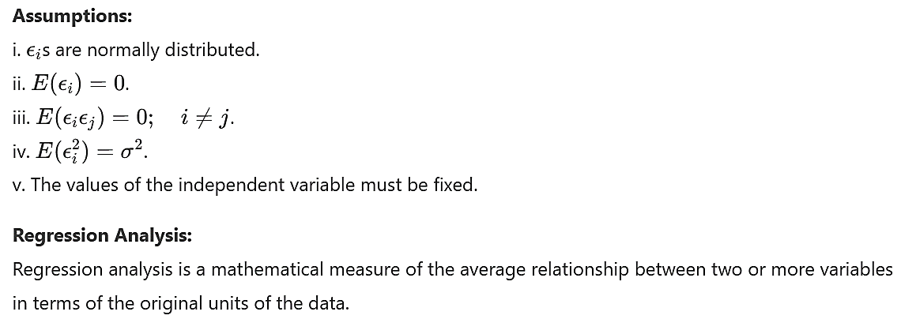
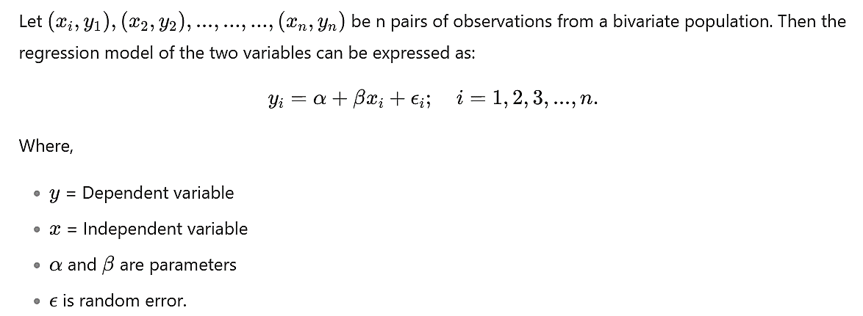
The two Variable regression Model
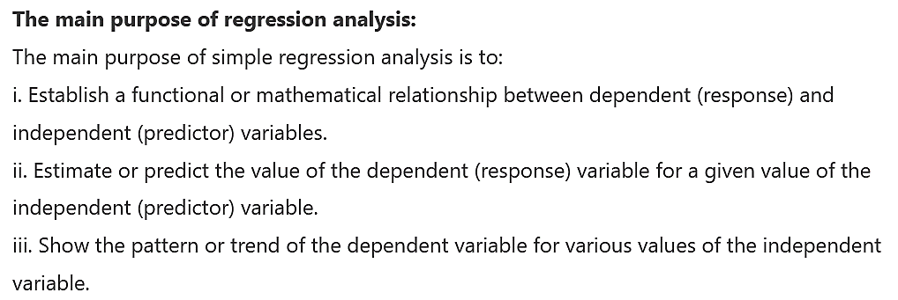
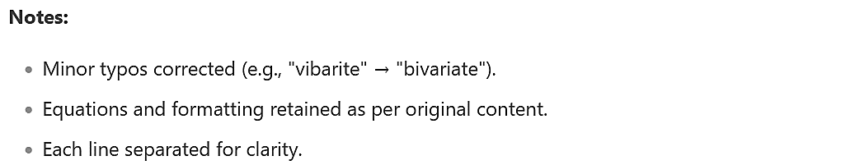
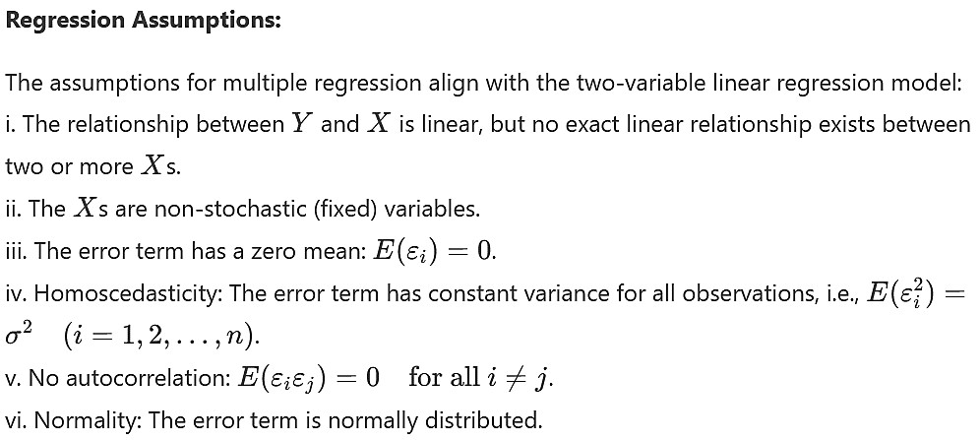
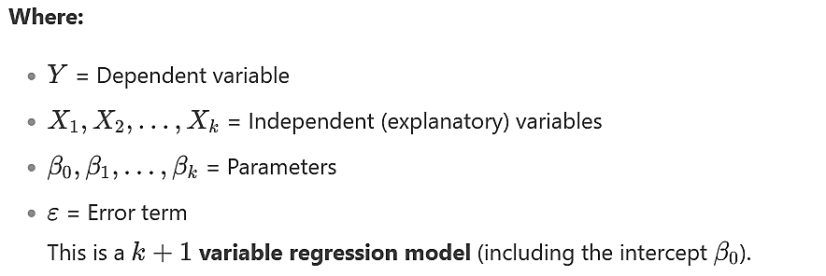
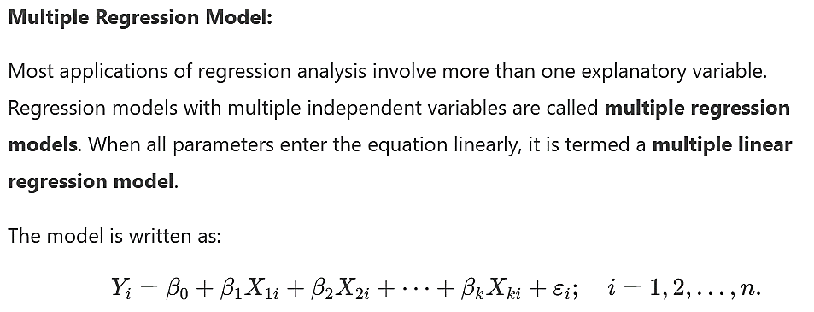
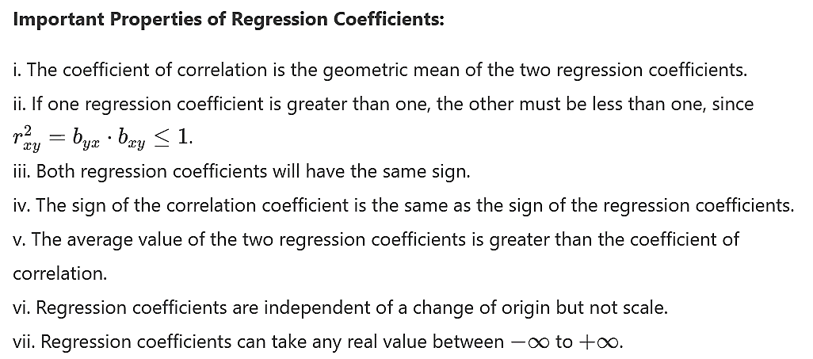
.

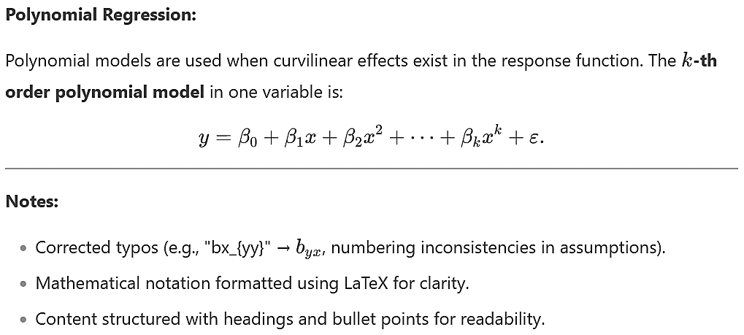


Correlation and regression
Correlation

Correlation: the statistical tool with the help of which these relationships between two or more than two variables can be studied is called correlation.

AM.Turtle gives a very simple definition of correlation. According to AM.Turtle, an analysis of co variation of two or more variables is usually called correlation.

Note: the linear relationship between two variables is defined as correlation.

According to the nature of relations between two variables, correlation can be divided as
- Perfect positive correlation
- Partial positive correlation
- Zero correlation
- Perfect negative correlation
- Partial negative correlation

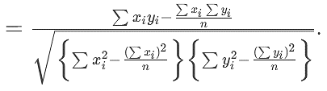
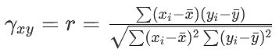
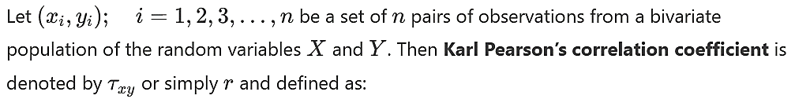
Correlation coefficient: A measure of intensity or degree of linear relationship between two variables is called coefficient correlation.

Important properties of correlation coefficient:

i. The correlation coefficient r lies between -1 and +1
ii. It measures the magnitude and direction of statistical relationship between two variables
iii. It is a pure number. That is, it is independent of the units of the measurement of the variables
iv. It is symmetrical function of x and y, that is r_xy = r_yx
v. r = 0 indicates no linear relationship between x and y
vi. r = +1 indicates a perfect positive relationship between x and y
vii. r = -1 indicates a perfect negative relationship between x and y
viii. The geometric mean of the two regression coefficients is equal to the correlation coefficient
ix. The correlation coefficient is independent of the shift of origin and change of scale.

The main purpose of the correlation:
- Correlation is used to describe the linear relationship between two continued variables (e.g., height and weight). In general, correlation tends to be used when there is no identified response variable. It measures the strength (qualitatively) and direction of the linear relationship between two or more variables.

- The pearson correlation coefficient measures the strength of the linear association between two variables. It can be used to estimate the population correlation, $ρ$

Difference between correlation coefficient and regression coefficient:
Regression | Correlation
Regression means determination of estimated values of the independent variable with respect to one or more independent variables. | Correlation means the linear relationship of two or more dependent variables with each others.
In regression influenced variable is called dependent variable and other variables are independent. | In correlation the variables are dependent on each other variable. There is no concept of independent variables.
In regression, only the dependent variable needs to be random | In correlation, both the variables must be random
In regression, either  $y=f\left(x\right)or x=f(y)$  or both may be true . | In correlation, either  $y=f\left(x\right) and x=f(y)$  are to be true .
$$b_{xy}≠b_{yx}$$ | $$r_{xy}≠r_{yx}$$
It has no upper and lower limit | $$-1≤r≤+1$$
Regression coefficient are independent of change of origin but not of scale | It is independent of both change of origin and scale.

